\\\\\\\\\\\\Rubber Ducky Lab 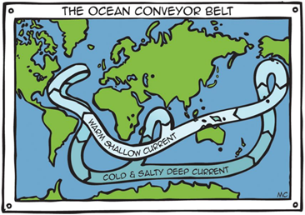

1. This is a depiction of ocean currents called the Ocean Conveyor Belt. The ocean conveyor belt is caused by differences in water temperature and salinity. Also known as thermohaline circulation, the conveyor belt is a system in which water moves between the cold depths and warm surface in oceans throughout the world. **Draw the Ocean Conveyor Belt on your World Map with a Blue colored pencil.**

2. **Mark 44◦N, 178◦E on your map with a black colored pencil. In** this location, in 1992, a cargo ship full of bath toys spilled nearly 92,000 rubber ducks into the Pacific Ocean. These ducks traveled thousands of miles on ocean currents, providing new information about these currents. For example, the first group of ducks to make landfall washed up on the shores of Alaska.

3. Make a prediction of where the ducks traveled, based on the Ocean Conveyor Belt. **Mark the map with a yellow colored pencil where you think the ducks washed up on shore.**

4. **Read the article, How Rubber Ducks Reveal the Ocean Currents.** **Mark the areas where the ducks actually came ashore with a red colored pencil.**

5. How accurate were your predictions? Our prediction was pretty accurate because the red dot was exactly where we put the yellow dot.

6. How can this assist us with Ocean pollution? This can assist us with Ocean pollution by telling us how much garbage moves to each place throughout the ocean.

**Rubber Ducks Reveal the Ocean Currents**

By Richard Joy • 26 May 2015

**In 1992, 28,000 rubber ducks were plunged into the ocean after a shipping crate was lost at sea on its way to the US from Hong Kong.**

At the time it was put down as a commercial loss and soon forgotten, yet years later the rubber ducks are now seen as a vital tool in our understanding of ocean currents, as well as teaching us about pollution, according to Mother Nature Network.

After being dunked in the Pacific Ocean, the ducks made it halfway around the world, washing up on the shores of Hawaii, Alaska, South America, Australia as well as the Pacific Northwest. Some ducks were even found frozen in Arctic ice, while other ducks made their way as far as Scotland.

The ducks are now known as the “Friendly Floatees” by researchers who have tracked their progress over the years. This map details the extent of the ducks travels:

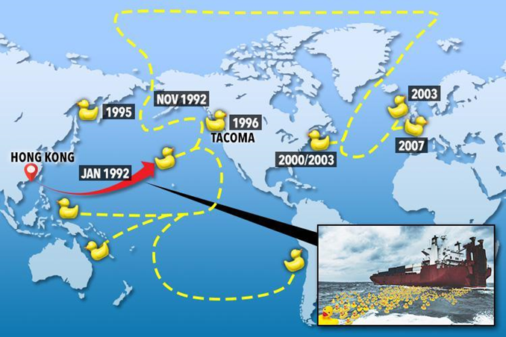

2,000 of the ducks circulate the currents of the North Pacific Gyre – a vortex of currents which stretches between Japan, Alaska, Kodiak and the Aleutian Islands – that the plight of the duckies helped to identify.

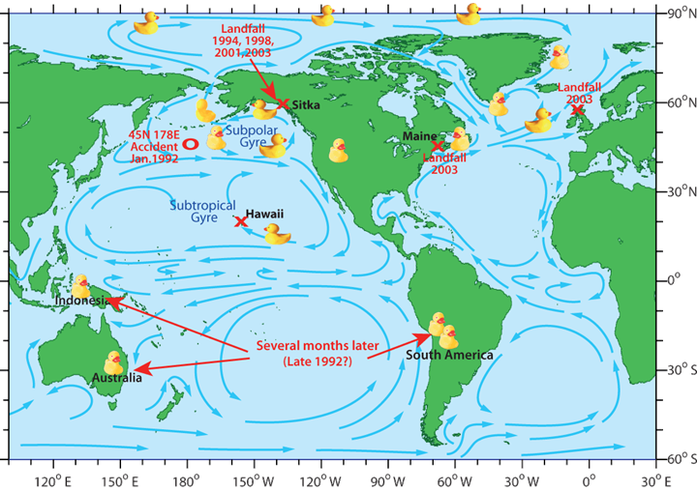

Researchers now know that it takes a current three years to circulate the full current by monitoring the ducks’ progress.

Furthermore, the ducks also brought attention to a huge garbage patch which has formed in the North Pacific Gyre, furthering evidence that ocean trash forms in the ocean’s gyres.

The Friendly Floatees are still washing up to this day and have been the feature of a book chronicling their journey entitled Moby Duck.